SAMPLE - Evaluation of Surface Defects in Glass by Fractal Geometry and Statistical Analyses
Vlastimil Hotař

Introduction
Many natural structures cannot be described by conventional methods, because they are complex and irregular. A new approach is …

Methods of analyses
The explicit, objective and automatic description of images complexity can be made by different methods both statistic and fractal dimension [1].
An evolution of a structure is possible by a description of a histogram, fig. 1.

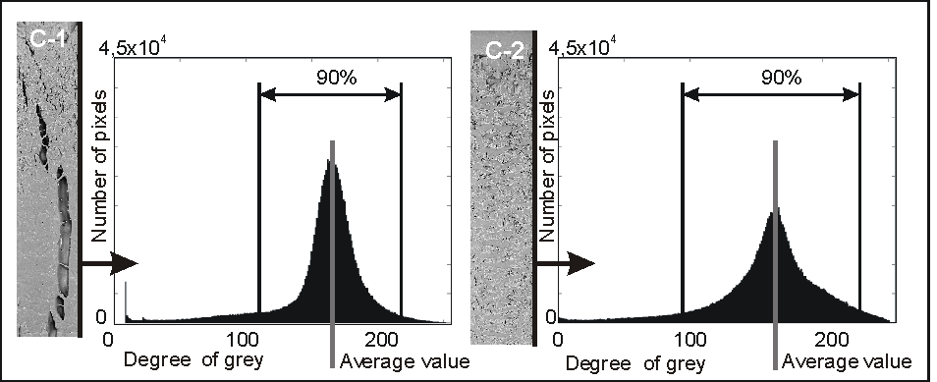
Fig. 1 Histogram cut off on 5% level

Conclusion
Photos of structures can be described by the statistic analysis and …
Tab. 1 Chemical composition of experimental melts of the studied alloys
Koncentrace prvků v % hm
slitina | C | Mn | Si | Cr | Fe | Nb | W | Co | Ta | Zr | Ni
M2 | 0,37 | 0,37 | 1,00 | 27,09 | 6,87 | 2,50 | 6,04 | 5,83 | - | - | zb.
M3 | 0,36 | 0,34 | 0,89 | 29,61 | 7,24 | 2,79 | 7,28 | 8,92 | - | - | zb.
141I | 0,34 | 0,58 | 0,55 | 26,5 | 7,97 | 0,99 | 4,94 | 4,47 | 0,93 | 0,05 | zb.

References
[1] MANDELBROT. B. B. The fractal geometry of nature. New York: W. H. Freeman and Co.,1982.

Summary
The article demonstrates possibilities of the fractal geometry with combination of statistic tool for... (in range approximately 10 -12 lines)

Ing. Vlastimil Hotař, Ph.D., Department of Glass Producing Machines and Robotic, Technical university of Liberec, Studentská 2, 461 17, e-mail: vlastimil.hotar@tul.cz, tel.: +420 485 352 929

